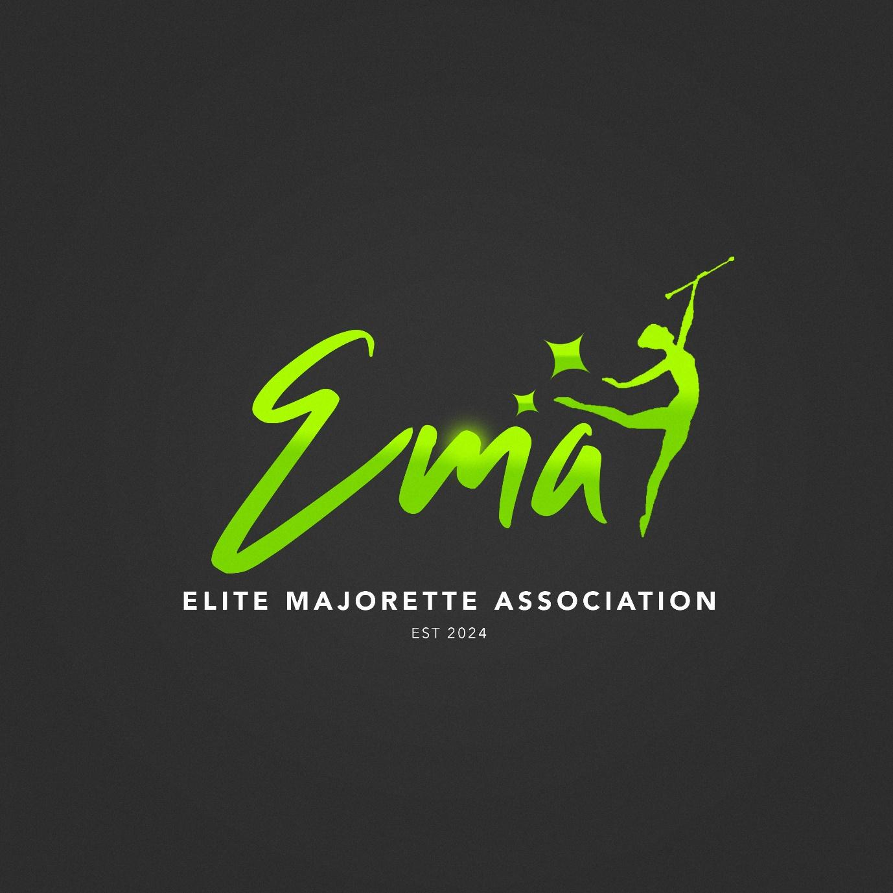

RULE BOOK

ROUTINES, AGES AND TIMING
Routines
MILITARY
MILITARY FREESTYLE
BATONS
POMS
FLAGS
COMBINATION

Age Groups
TINY - AGE 9 AND UNDER : 2-3 MINUTES

JUVENILE - 12 AND UNDER : 3-4 MINUTES

JUNIOR - 15 AND UNDER : 4-5 MINUTES

SENIOR - 16+ : 5-6 MINUTES

COMBINED ROUTINES
(I.E TINY JUVI/JUNIOR SENIOR)
12 AND UNDER : 3-4 MINUTES
13 AND OVER : 5-6 MINUTES

MINIMUM NUMBER OF DANCERS PER ROUTINE: 3

Military rules
(applicable to all age groups)
- A marching routine
- No dance movements are to be utilised
- One baton is to be used for dead stick movements and for struts only
- No floor work is permitted
- Military music is to be used
- No throws, flips, twirls or illusions are to be performed

Expectations
- A variety of well executed formations
- Range of marching techniques
- Footwork (pointing/stepping/high knee march/majorette march)
- Struts
- Left and right hand usage
- Skirted leotard/military skirt and jacket

Judging
- Straight lines and overall formation execution
- Well executed transitions between formations
- Togetherness
- Variety of shapes and formations
- Posture
- Content of struts
- Personal presentation
- Use of arena

Military Freestyle rules
(applicable to all age groups)
- No dance footwork is to be utilised
- Basic twirls
- Variety Struts
- Well executed formations
- No throws flips or illusions are to be performed
- No floorwork is permitted
- Simple wraps and rolls
- No music limitation will be imposed
- Skirted leotards are preferred

Expectations
- Well executed formations
- Range of footwork and marching techniques
- Simple roles and wraps
- Simple twirls
- Variety of struts
- Left and right hand usage

Judging
- Togetherness
- Straight lines
- Well executed formations and transitions
- Content of expected twirls
- Range of foot work and marching
- Use of arena

Baton rules
- A standard well fitted baton/two batons can be used
- Twirls should be safely executed and cohesive to the standard of the age group and twirlers
- No gymnastic movements are to be performed
- No dangerous throws or exchanges are to be executed
- Dance moves and dance footwork are permitted
- No dress requirement
- No music requirement
- Appropriate floor work is expected

Expectations
- A variety of well executed twirls
- A variety of well executed rolls and wraps
- A range of well executed throws flips and illusions
- A range of well executed formations and transitions
- A variety of footwork and dance movements
- Left and right hand use

Judging
- Well executed twirling content as described in the expectation section
- Variety of twirling content
- Togetherness/timing
- Well executed formations and transitions
- Entertainment
- Performance/showmanship
- Presentation
- Control and ability
- Use of arena

Pom rules
- Poms are to be used at all times
- No lifts or gymnastics movements are to be performed
- No inappropriate dance movements
- No dress requirement
- No music limitation
- Poms should be twirled, punched and shaken
- Dance movements are permitted
- Appropriate floor work is expected
- No throws are permitted

Expectations
- A variety of dance movements
- A range of formations and transitions that are well executed
- A variety of pom movements

Judging
- Entertainment
- Togetherness/timing
- Performance/presentation
- Well executed formations and transitions
- Showmanship
- Variety of expected content included
- Use of arena

Flag rules
- One or two flag may be used at a time
- A variety of flags can be used i.e big silk/baton flag/double ended flag throughout the routine
- Twirls should be safely executed and cohesive to the standard of the age group and twirlers
- No gymnastic movements are to be performed
- No dangerous throws or exchanges are to be executed
- Dance movements and footwork are permitted
- No dress requirement
- No music requirement
- Appropriate floor work is expected

Expectations
- A variety of twirls
- A variety of rolls & wraps and throws
- A range of well executed formations and transition
- A variety of footwork and dance movements

Judging
- A variety of well executed twirls and movements
- A variety of twirling content
- Togetherness/timing
- Well executed formations and transitions
- Entertainment
- Performance/showmanship
- Presentation
- Left and right hand usage
- Use of arena

Combination rules
- A themed routine
- Appropriate costumes are to be worn
- A variety of equipment is to be utilised
- The routine should be entertaining
- Music appropriate for the theme should be used and interpreted as appropriate
- A variety of twirls flips, throws, and illusions(of any prop/equipment )

Expectations
- Entertaining content
- Majorettes movements
- Footwork and dance movements are to be utilised
- Musical interpretation

Judging
- Entertainment
- Showmanship
- Variety of formations/transitions
- Usage of props and equipment
- Variety of twirling content

Leader/Drum major rules
- The Leader should be easily identifiable to the designated judges throughout the routine.
- The Leader should start at the front of the routine and give commands to the rest of the dancers in the arena. These should include calling their team to ‘attention’ and to ‘positions’ meaning the dancers will now be ready for the music to begin
- A Leader is recommended to begin the routine by twirling a mace however they may also use the current routines equipment if they wish to do so in place of the mace
- In a Military section the leader should utilise a mace for the duration of the routine. This should be used to conduct basic twirls, rolls and wraps but should mainly be used to command their team through signals.The mace should not be thrown or flipped in this routine
- A Leader must be the first person to exit the arena
- A leader must ‘halt’ and ‘dismiss’ their dancers once they have exited the arena
- The Leader should salute at either the beginning or end their mace performance at both the beginning and end of the routine
Expectations
- A variety of well executed movements with their chosen equipment which can include a variety of twirls, wraps, rolls and safe flips and throws completed at the beginning and end of the routine
- Clear and confident commands at the beginning and end of a routine
- Confident presentation
- An entertaining, well executed performance throughout the routine
Judging
- A Leader will be judged separately as well as alongside their teammates
- Technical ability when utilising both a mace and the designated routines equipment
- Performance/showmanship
- Personal presentation
- Command of the team
- Cohesion/teamwork

Mascot rules
- A Mascot should be easily identifiable to the designated judges at all times
- In a Military section a Mascot is permitted to use a mace alongside the leader if they wish to do so

Expectations
- An entertaining performance
- An entertaining, well executed performance throughout the routine
- A confident performance
Judging
- A Mascot will be judged separately as well as alongside their teammates
- Performance and personality
- Showmanship
- Personal presentation
- Cohesion and teamwork

General rules
- Each routine should have a Mascot and a Leader who are clearly identifiable to the judges at all times
- A Mascot or Leader will be judged separately as well as alongside their teammates
- A Leader should be the first dancer to exit the arena
- A mace is recommended to be used by the Leader at the beginning and the end of the routine
- The leader should make commands at the beginning of the routine to call their team to attention and to position themselves ready to begin (these commands are recommend to be verbal however non verbal commands will also be accepted)
- Teams must salute at the beginning and end of a routine this can be in the teams own style either using a Majorette salute or a baton salute
- All routines must start on the arena and will be timed from the first beat of the music
- A mace should be of an appropriate height. This means the crown of the mace should stop between the dancer's shoulder and nose (excluding tinies). A point deduction from the Leaders own score can be incurred for the utilisation of an incorrect mace
- Maces should be of a premier standard. A point deduction can be incurred from the leaders own score if an incorrect mace is utilised
- Uniforms/leotards should be appropriate and fit dancers well
- Cheer or federation poms may be used
- Music should not include swearing or inappropriate content
- All routines should end outside of the arena with the dancers exiting through a designated exit
- All routines must be dismissed outside of the arena by their leader through a command (verbal commands are preferred however non verbal commands are also accepted)
- Injuries should be assessed accordingly and dancers should only compete if safe to do so
- 1 point per rule break can be deducted at the judges discretion and can be used for:
- Unsafe twirls
- Extending a routine over the allotted time limit
- Incorrect mace size (Leader)
- Inappropriate baton lengths
- Inappropriate dress

- The chairpersons will have the final decision regarding disqualifications. Disqualification can be caused by :
- Inappropriate troupe behaviour
- Rule breaking
- Unsportsmanlike behaviour

- No photography or videos should be taken of any team other than your own
- Photos and video are to be taken from the front of the arena only
- Troupes should be on time and ready for their allocated slot
- Dancers changing teams are only permitted to dance at EMA with their previous troupe leader's permission. If this is not granted the dancer must wait for a new EMA season to begin before they are able to compete with their new team
- No alcohol will be permitted within competition venues (during the times in which a competition is being conducted)
- All teams will require public liability insurance in order to compete
- Teams must have the correct structure to run in order to be eligible to compete at EMA
- All payments should be made on or before the allocated date set out by the chairpersons

